Mohd Hisyamudin Bin Abd Aziz  
BI19110028

**Question 1**

Add Menu Bar at the top with menu ‘Load Data’ to read from file and view in the output textrea. Menu ‘Exit’ to show ‘showConfirmDialog’ and exit the application if user select ‘yes’ in the dialog.

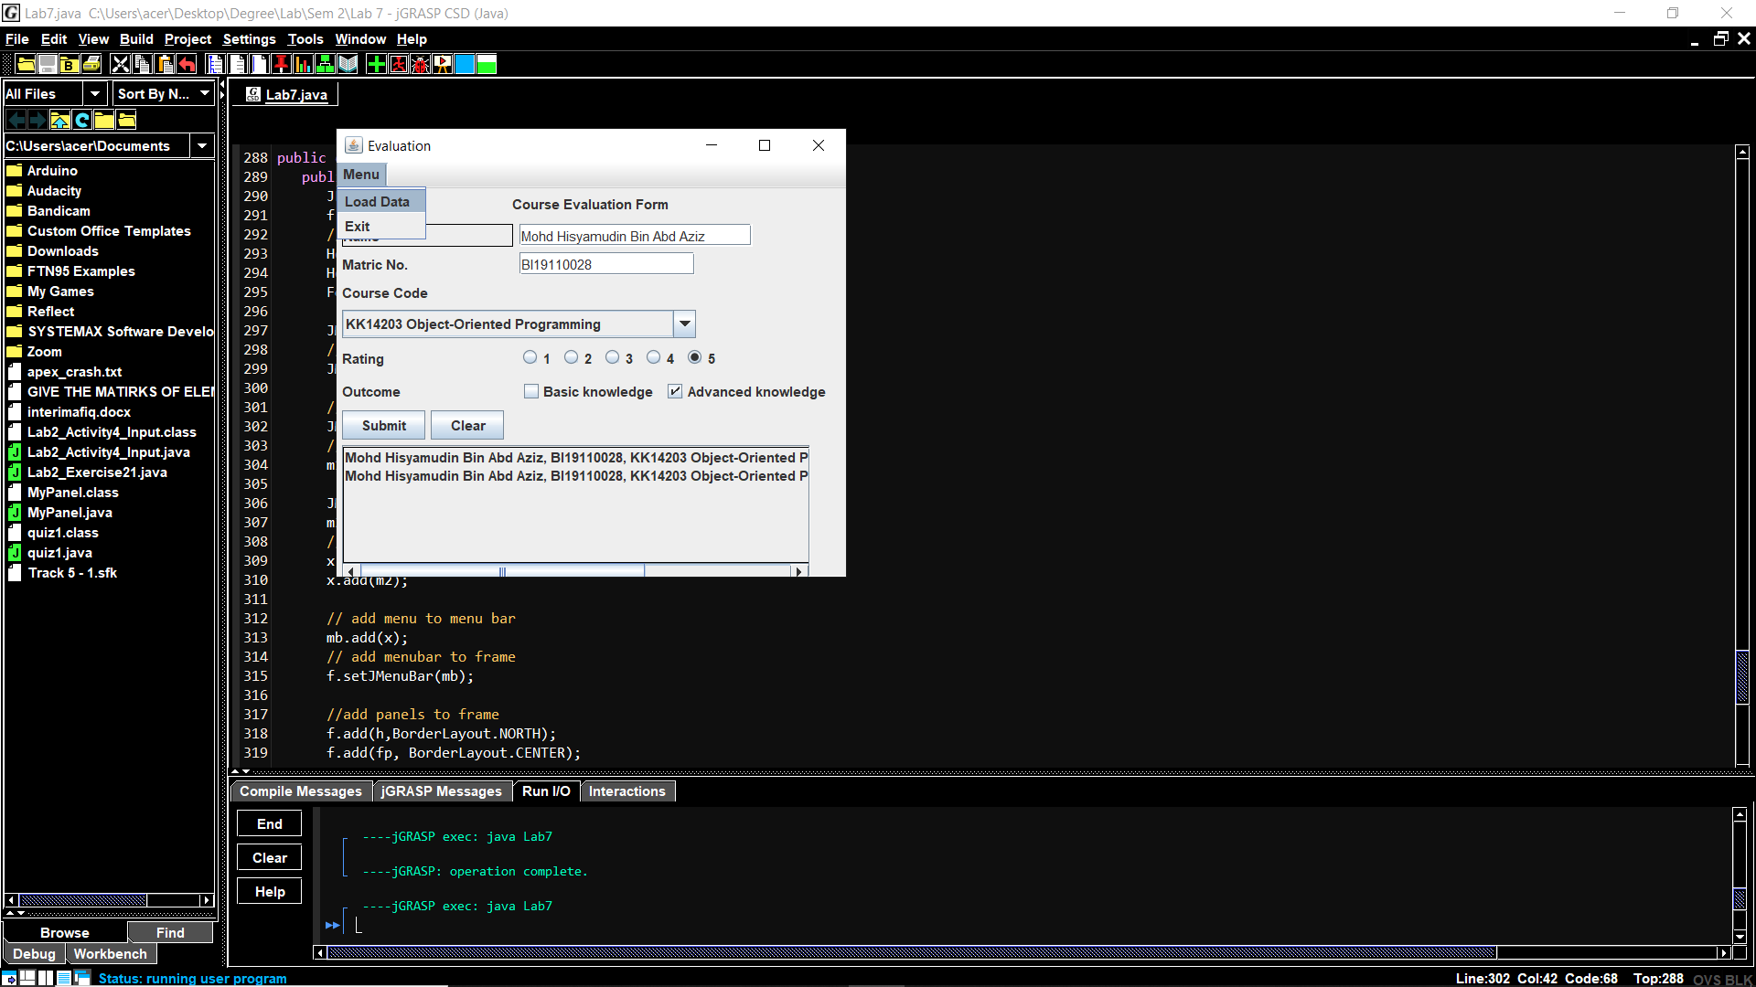

**Figure 1:** Menu Bar at the top with menu ‘Load Data’ to read from file and view in the output textrea.

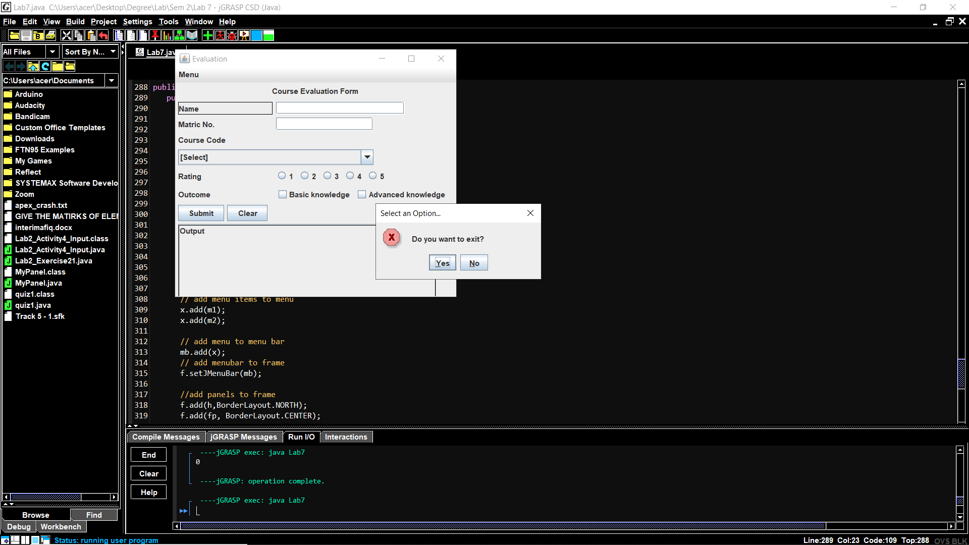

**Figure 2:** Menu ‘Exit’ to show ‘showConfirmDialog’ and exit the application if user select ‘yes’ in the dialog.

**Question 2**

Input validation from all input to check if user empty field or selections when user click ‘Submit’ button.

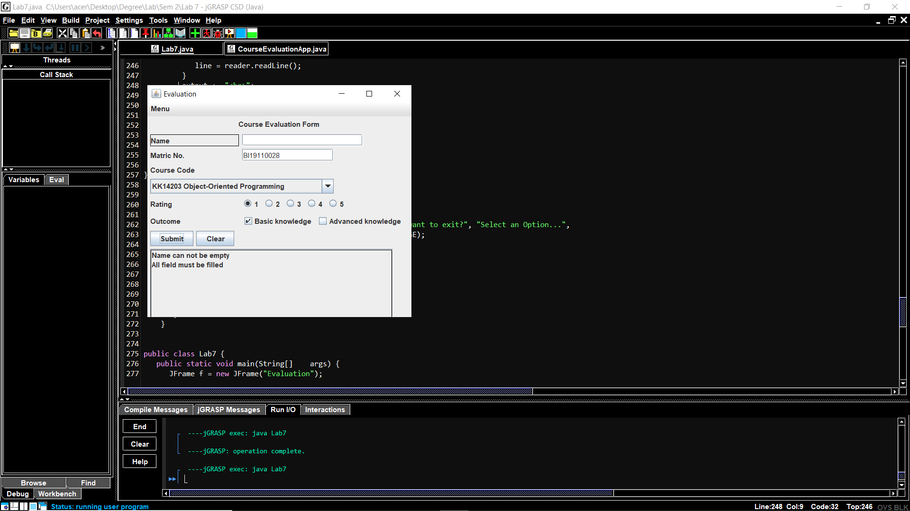

**Figure 3:** Name could not be empty.

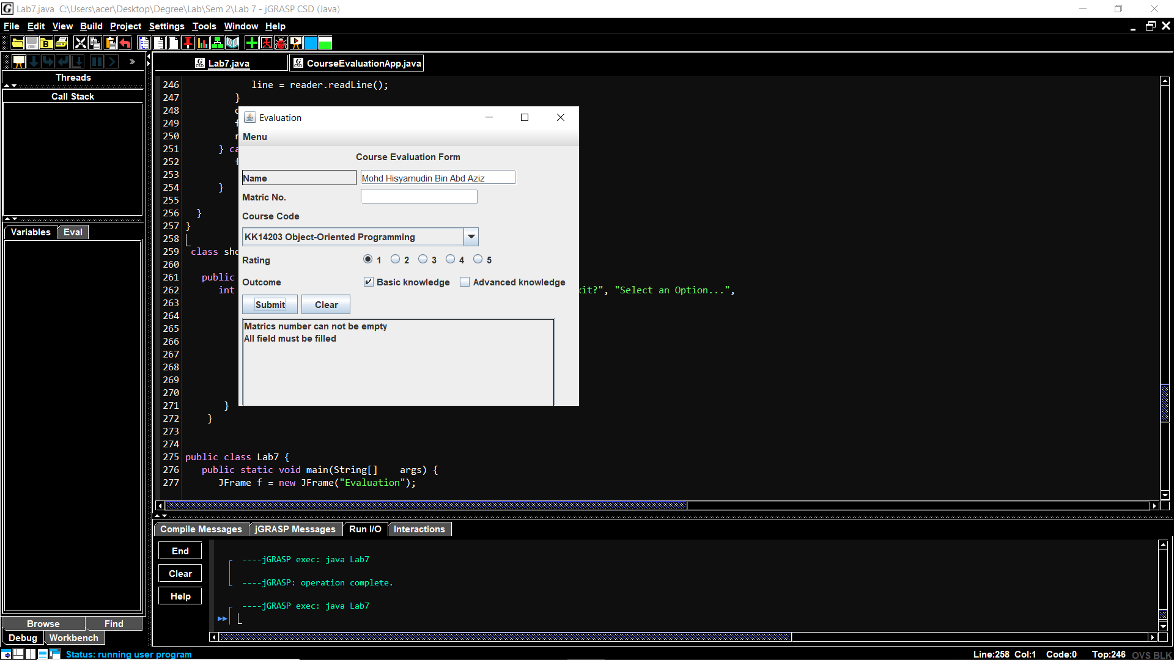

**Figure 4:** Matric number could not be empty.

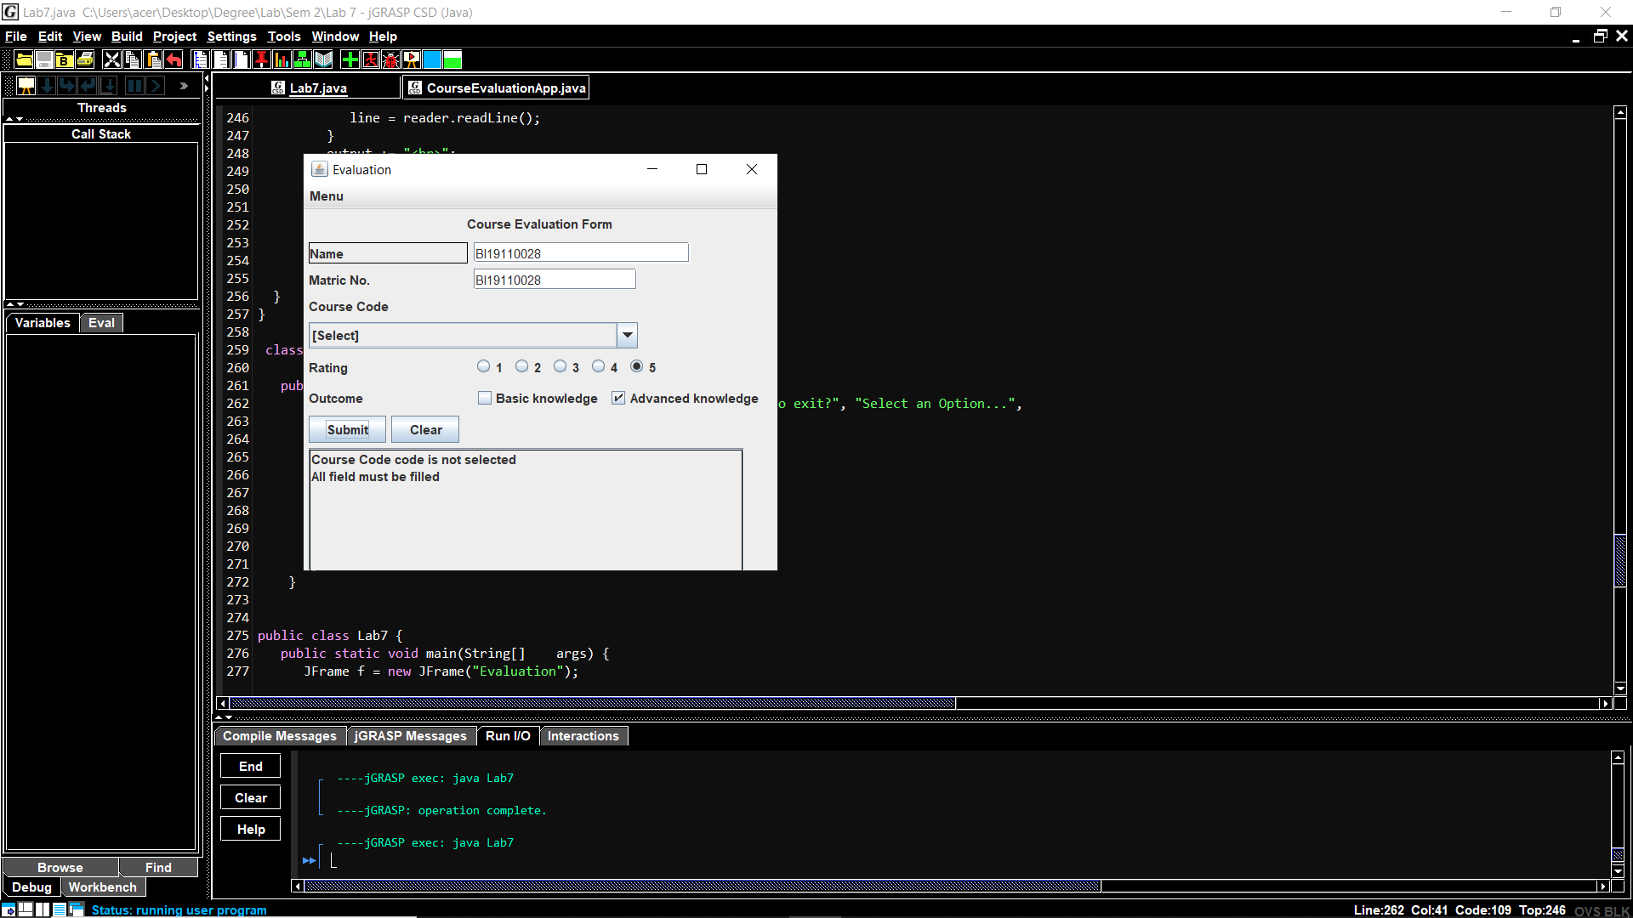

**Figure 5:** Course code could not be empty.

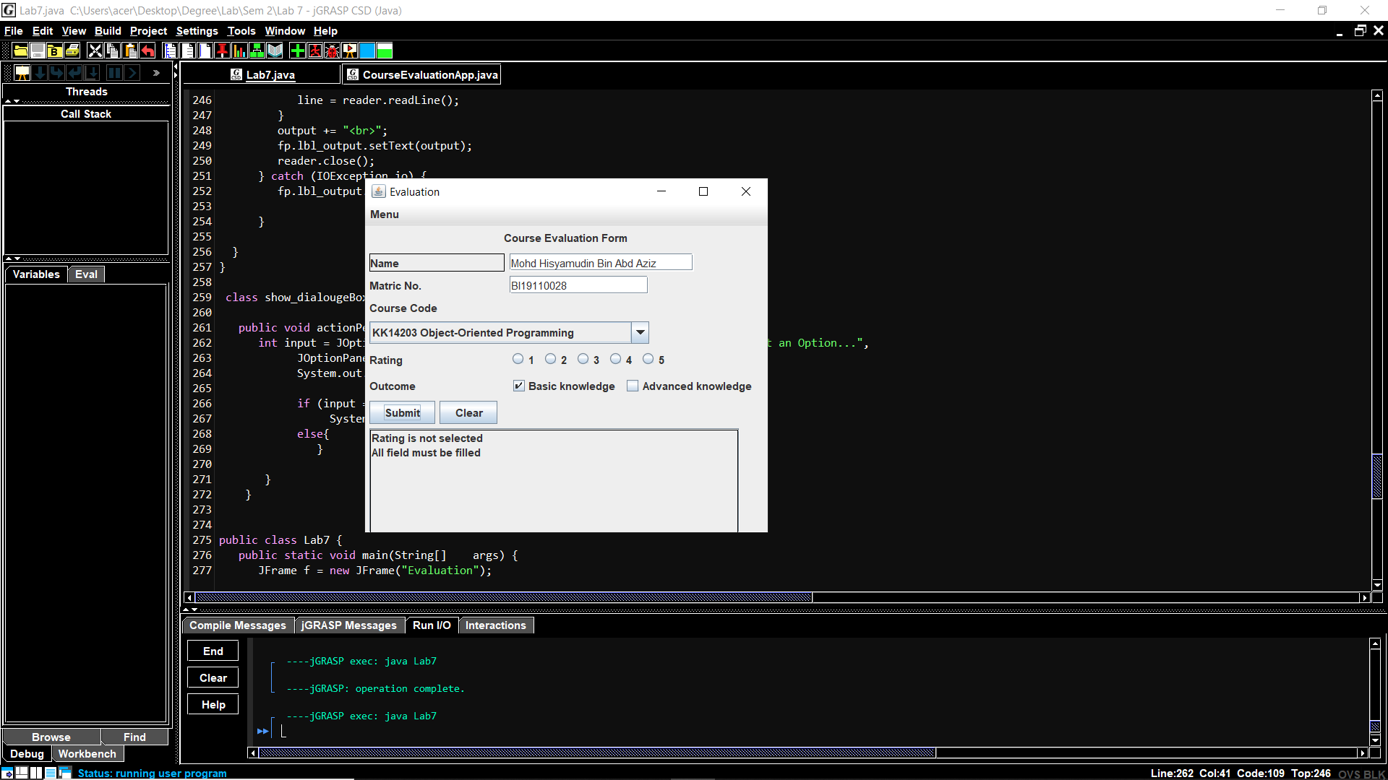

**Figure 6:** Rating could not be empty.

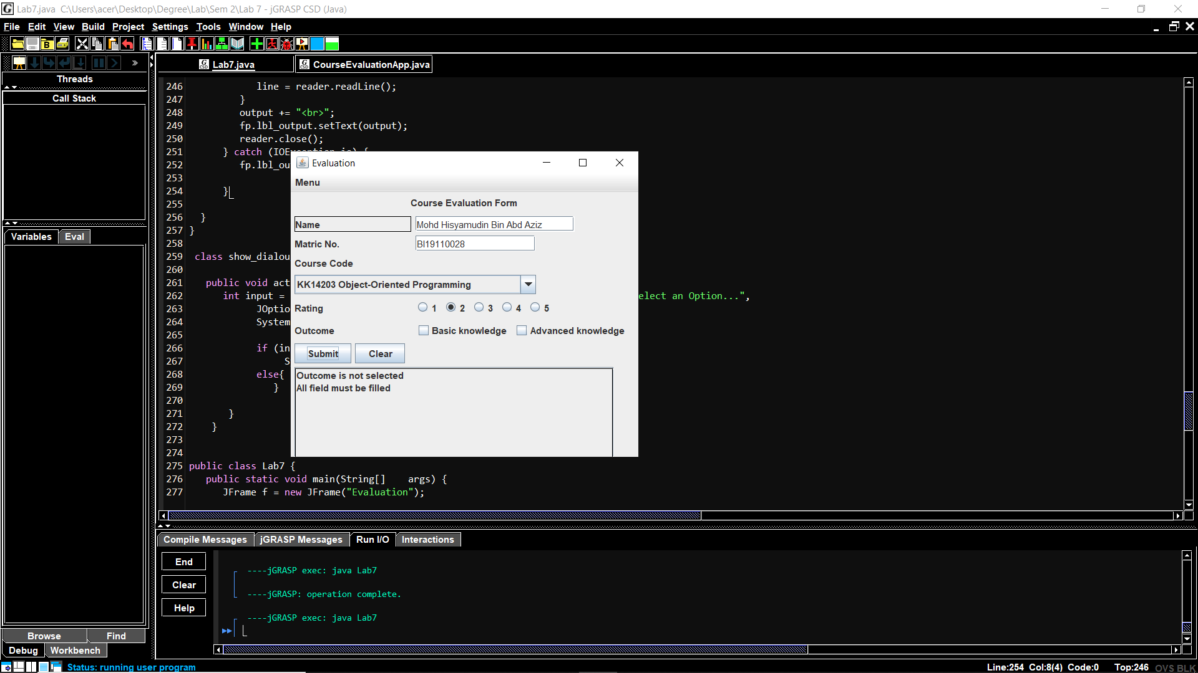

**Figure 7:** Outcome could not be empty.

**Question 3**

Save (add) the data into a text file with dialog notification (e.g. showMessageDialog) whether input is successfully saved.

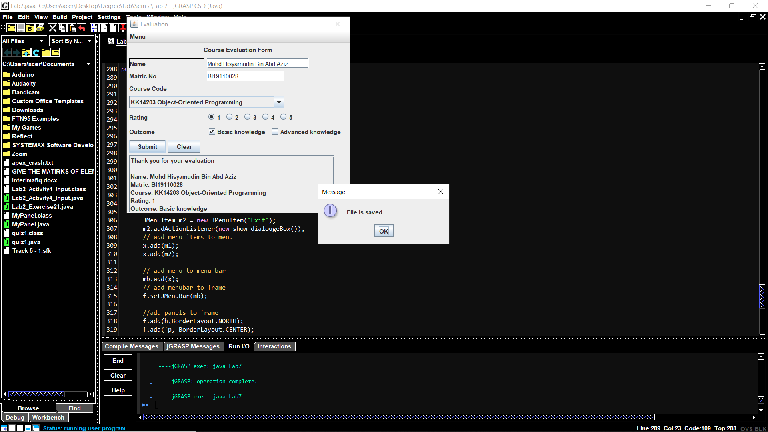

**Figure 8:** Save the data into a text file with dialog notification.

**Question 4**

Implement at least ONE (1) exception handling (e.g. file IO and dealing with empty input field.

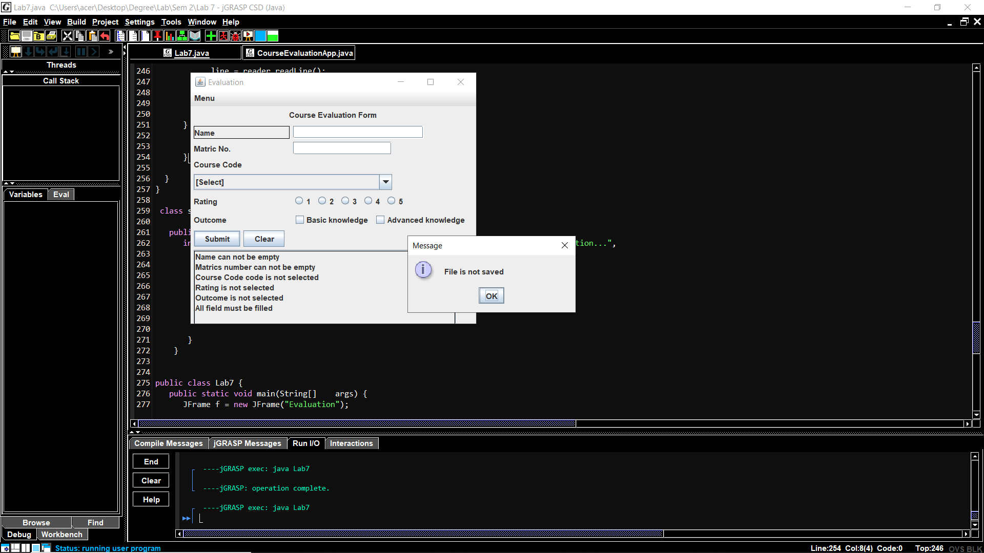

**Figure 9:** If any of the field is empty, a message will appear saying “Please fill all the fields”.

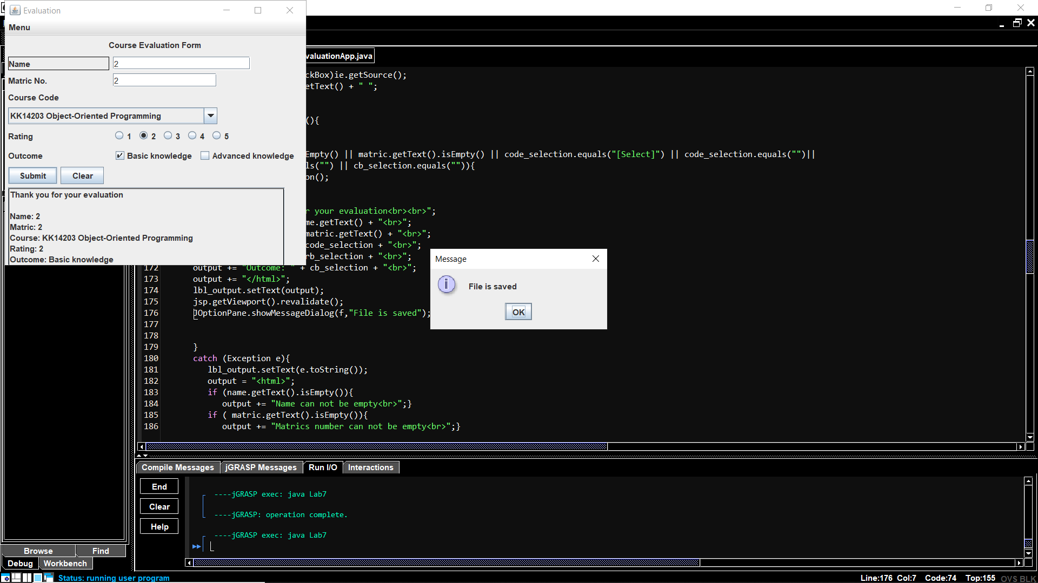

**Figure 10:** If all of the field filled, a message will appear saying “File is saved”.